[**www.nelspruitmarathonclub.com**](http://www.nelspruitmarathonclub.com)

***Nelspruit Marathon Club***

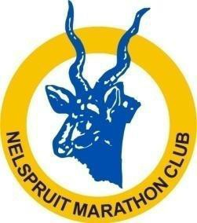

## Email: [info@nelspruitmarathonclub.com](mailto:info@nelspruitmarathonclub.com)

**Tel: 083 951 0380**

Thank you for joining **NELSPRUIT MARATHON CLUB.** We hope that you will enjoy your membership during 2023 and that you will be successful in your running goals, whether these are merely improving your fitness in a social setting, racing competitively or anything in between.

We would very much like club members to get to know each other better in an informal and social setting. After all, running should not be (*just*) about running.

Secondly, the spectacular growth during recent years of our two annual races, the **NMC FAST 3 in 1** and the **KAAPSEHOOP 3 in 1 Marathon**, has greatly increased the administrative and organizational work-load involved in hosting them successfully. Our races attract large numbers of runners from all over the country, and these races are no longer merely local club events, but are showpieces for Nelspruit and for the Lowveld. We always need more willing hands on, before and even after race-day.

In light of the above, we kindly request that you take note of the points listed below and, if you agree with these stipulations, to sign this form.

# Nelspruit Marathon Club undertaking and League Participation

## I hereby declare that as a member of Nelspruit Marathon Club, I agree to the following:

1. As per the rules of regulations not only of the Nelspruit Marathon Club, but also Athletics South Africa**, I undertake to wear the full club colours of Nelspruit Marathon Club when participating in any official races.** I also undertake to wear the correct and appropriate age category tags to qualify for age- or category prizes when participating in official races.

*Our club colours are old gold and royal blue. The running vests are royal blue and the shorts/skirts are old gold.* ***NO black or blue shorts or skirts may be worn.*** *Ski-pants may only be worn on their own only if they are the official royal blue pants with old gold markings.*

*The new approved club colours must be worn by all club members as approved during the 2016 AGM. This is the vest with the old gold writing. Running any official race in the old vest with white writing could result in your disqualification from that race. Please take note that rules regarding running attire during formal races are contained in the new 2018 ASA race rules, and are not simply Nelspruit Marathon Club rules.*

*The official running clothes are available at Unity our supplier Monday to Friday.*

1. I undertake to keep time at least once during the year during our weekly time trials. Each member will be assigned to one of the 4 (four) teams in the club. Your Team Captain will notify you regarding which team you have been assigned to. Allocating club members to teams facilitates the administration of the club and of time trials, but teams will also participate in friendly in-house competitions and challenges, to build team spirit.

Most of these challenges will be on the last Thursday of the month, when we also traditionally have a bring and braai for club members, their family and friends.

Please complete and bring together with your completed signed form; copy of ID and ID photo and proof of payment to the club. A hard copy needs to be kept on file as well as to be send to AMPU.

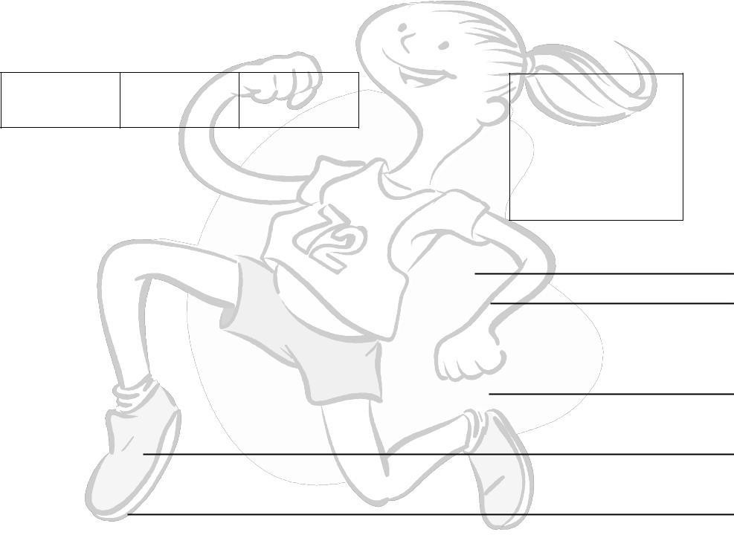

**Membership as League participant: (please indicate one)**

**ID photo: (please attach)**

Runner

Walker

Social

Member

ID photo

**Best achievement:**

**Started running:**

|  |  |
| --- | --- |
| **Name:** | **Surname:** |
| **Male/ Female:** | **Nationality:** |
| **Cell phone number:** | |
| **Email:** | |
| **Date of birth:** | **ID Number:** |

**Signed by: on this date**

**Member’s Signature Club Chairman’s Approval**

## Membership Fees:

|  |  |
| --- | --- |
| Single Membership including the ASA fees for 2023 | R200 |
| Junior Membership including the ASA for 2023 | R120 |
|  |  |
| **Copy of ID required for ASA** | |

**Bank details:**

**ABSA bank**

**Branch code 632 005**

**Account No. 405 537 4317**

**Ref.no: Initial and Surname + club fees.**

**(Kindly e-mail your proof of payment to info@nelspruitmarathonclub.com)**

**MISCELLANEOUS**

**Helping out at club races**

We kindly request that you indicate whether or not you are willing to assist in working on our official races. “Working” could include any of a number of duties, including helping out at water tables, acting as a race marshall, helping with entries, basic race administration, or any of a number of other duties, as dictated by your willingness and availability. These duties will also not necessarily take place on race day itself but could take place in the days before the race, and will not necessarily preclude your participation in that race. The more people who help, the less time will be required by any given individual.

I am prepared to assist at the following races (Tick one or more)

|  |  |
| --- | --- |
| NMC Fast 3 in 1 | Kaapsehoop 3 in 1 |
| 25 March 2023 | 04 November 2023 |

|  |  |
| --- | --- |
| Post-race (NMC Fast 3 in 1 ) | Pre-Race (Kaapsehoop) |
| 1 April 2023 | 28 October 2023 |

## Time Trials

The club has partnered with Open Time Trial held forth nightly: on Tuesdays respectively.

Page **4** of **4**